Introduction to VB.NET

Objectives:

Open up and Start a Visual Studio, VB.NET, Project
Identify the Elements of the IDE
Design and Execute your First Project

Where to Look for Help:

www.Millburn.org/Farrell

Go to the CS 1 Link and goto the “Class Lecture and Documents” link

Teacher Notes, Program Example Code & other Items are in the
“Intro to VBNET” Topic

All Example Code or Projects are in ZIP format and need to be downloaded and UNZIPPED

VB.NET’s Online Help. Highlight any VB Object and hit F1 for Help

Visual Studio & VB.NET

Run Microsoft Visual Studio 2005 from either a desktop shortcut or by going thru START…ALL PROGRAMS

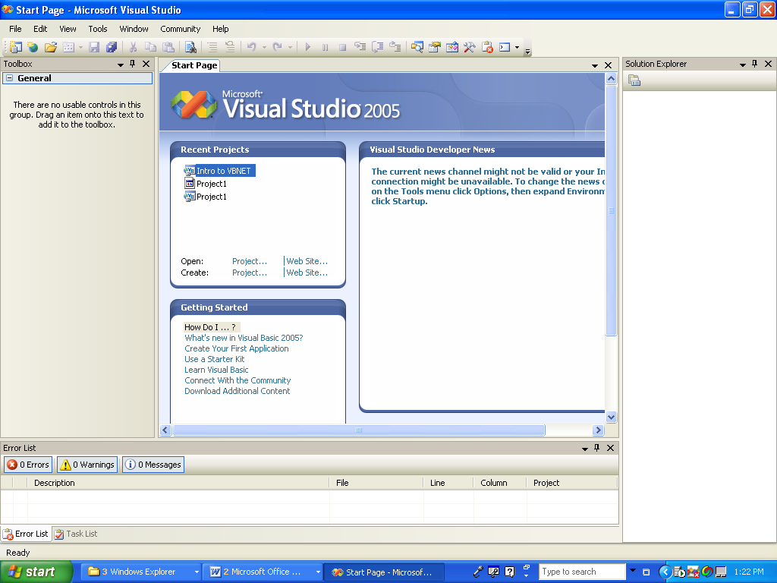

Then CREATE a Project:

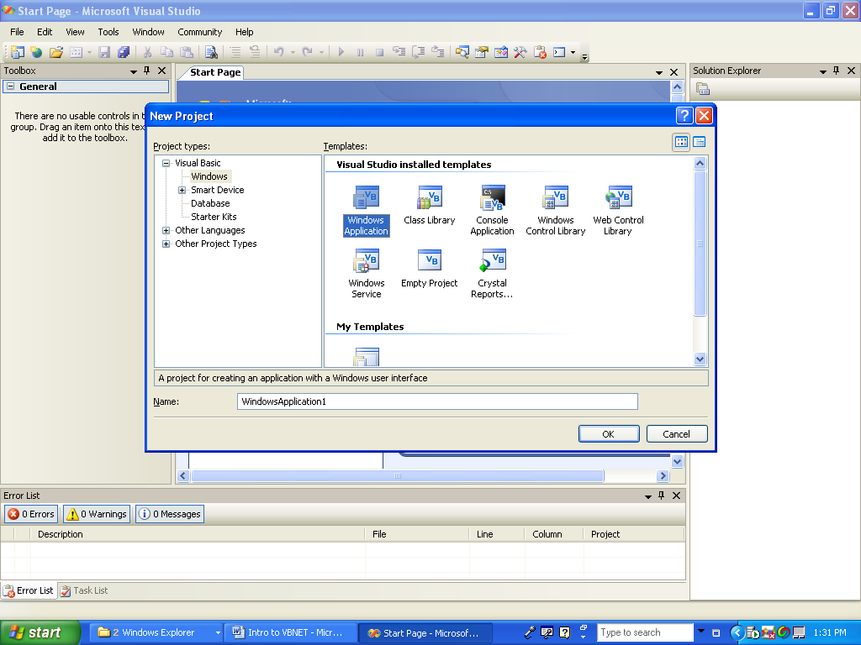

You will have a Project with a blank Form:

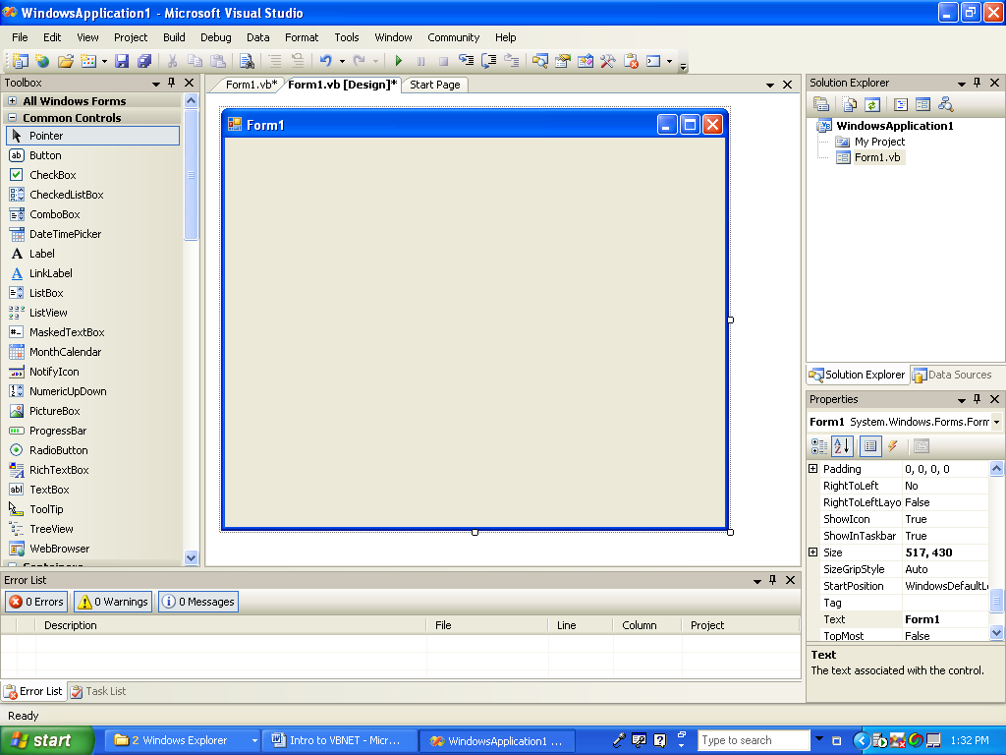

Identify the Elements of the IDE

The FORM is where all of the visible and non visible objects will be added

The Left of the window contains all of the OBJECTS you can add to the form:
Buttons, Labels, Text, Web Links…

The Center of the window contains the FORM

The Right side of the window lists all of the objects for this project

Click on the Form and View all of the Properties for that object

The bottom of the window displays Compile and Run Time errors and has the
Immediate Window

Design and Execute your First Project

“Hello World” Add a TEXTBOX, LABEL and BUTTON

Have the label say “Click the Button” by setting the text property
Code for the Button’s Clicked Event to have the Text say “Hello World”
By setting the text’s text property

Textbox1.text = “Hello World”

Run the Project with by clicking the PLAY Button

Notice the Code Completion, Compile and Run Time Errors on bottom

Notice Code Completion

Saving a Project

File SAVE ALL and then select an appropriate Name for this project, Hello World.
Select MyDocuments and then make sure you create a new Folder for this project.

Close Visual Studio

File Contents

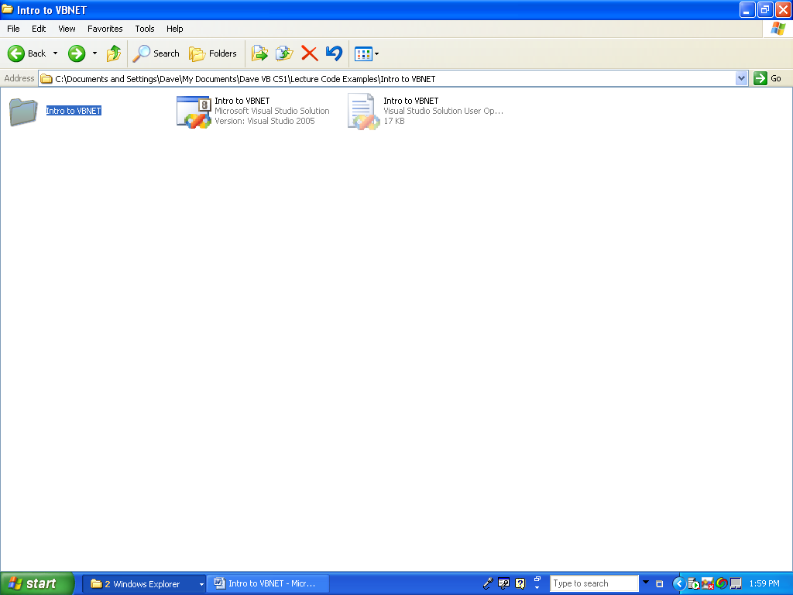

You can click on the VS Icon to open the project

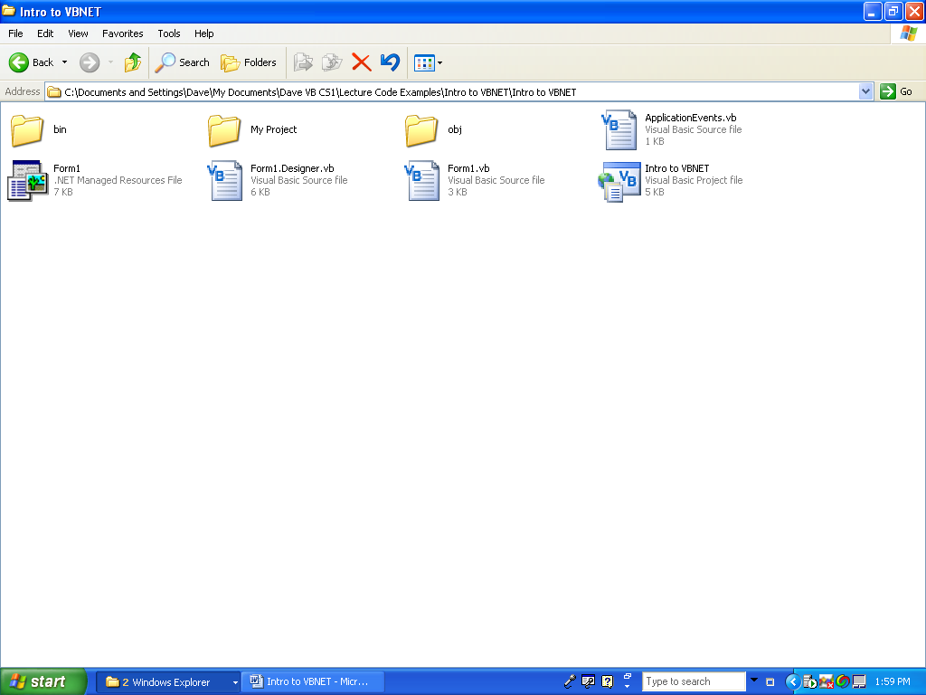

The “Intro to VBNET” Folder contains many sub folders and files.

My Project contains the SOURCE code

Examine and explain all of the other files created

Run Sample Project “Intro to VBNET”

Open and execute this project

Identify all of the objects used

Students Create a duplicate Version of this project

